Accountability………WHY?
Personal Accountability is the foundational building block for every performance improvement effort and is always the underlying factor of success in every organizational development effort, including:
Change Management
Execution Initiatives
Teamwork/Alignment
Employee Engagement
Leadership Effectiveness
Talent Management
Organizational Culture Change
Building Trust

Accountability is the guiding principle that defines how we make commitments to one another; how we measure and report our progress; how we interact when things go wrong, and how much ownership we take to get things done. It is, in essence, the nerve center that runs throughout every part of the organization, through every working relationship to every member of every team.

If accountability is not working in our organization, then every effort toward performance improvement will be inefficient and ineffective. The ability to execute and deliver results is directly tied to the accountability attitudes, practices and systems that are in place in an organization.

Accountability is often done in a way that can actually sabotage our ability to get results. We often hear people throughout an organization describe accountability as something that happens to them when things go wrong, when it should be something they do to themselves to ensure results and success.
How you go about creating accountability matters. Often, when done the wrong way, it leads to what we call the Accountability Paradox: that is, the harder you try to create accountability, the less accountable people actually become. This happens because people are reacting to the manner in which accountability is implemented.

Accountability, done effectively, is a skill you can develop just like any other skill. While it is not a difficult skill to acquire and hone, it does require a high degree of conscious effort. When you do it right, you'll also find it the fastest way to improve morale.
Greater accountability eliminates the time and energy spent in unproductive behavior that produces wasted effort and confusing distractions. Recent surveys show that the vast majority of people, at all levels of an organization, engage in these ineffective behaviors in their daily work. The price that is paid by both individuals and organizations for a lack of accountability can be significant. In a complex and challenging business environment, no organization can afford to pay the price for a lack of accountability. Unfortunately, people in most organizations only worry about accountability when something goes wrong, resulting in a "Run for cover" mentality when anyone mentions the word. By introducing a new view of accountability, a positive and principled view, accountability for results becomes something that everyone embraces as a helpful step in making things happen.

The real power of accountability comes when the focus is on taking greater personal accountability for achieving results. That personal accountability manifests itself as greater personal ownership, buy-in, investment and engagement. From time to time, leaders / managers tell us not to use the word "Empowerment" in because they are frustrated in their unsuccessful efforts to create it. Failed attempts to better enable people to overcome obstacles to achieving results leaves them skeptical about organizational initiatives designed to better "Engage" people. Empowerment, in the corporate sense, has become something someone does to you. Accountability, on the other hand, is something you do to yourself.
When you take personal accountability you own it. You tell yourself, this is mine, I've got the ball. You ask yourself, "What else can I do to make progress, overcome obstacles and achieve the result?" You don't waste time blaming others or waiting for someone else to solve your problems, you actively engage and deeply pursue solutions.

Today's challenging business environment. Creating a Culture of Accountability provides the key to the success of any organizational initiative.

Accountably has to be in line with all the company values and everything that all the company wants to achieve in the shortest amount of time.

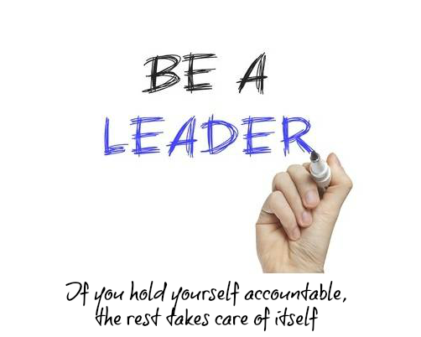
Click here to do your Accountability Assessment

