BODY LANGUAGE 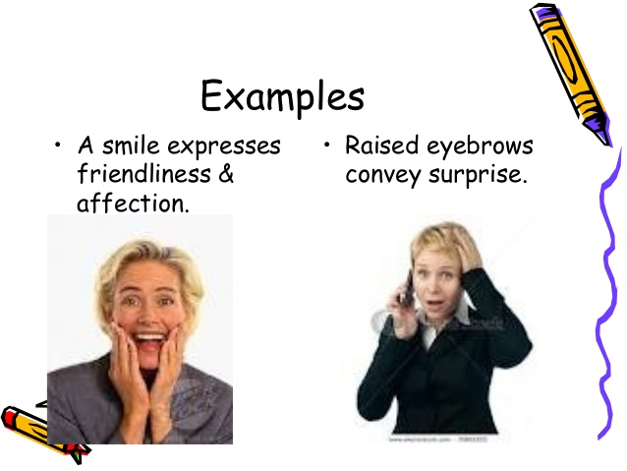
Did you know that 55% of our language to communicate with another person is non-verbal?
Our bodies can sense vibrations long before someone’s words arrive.

Most of us don’t even realize when we our bodies are communicating, so the first thing to do is to simply notice your body position. Customers respond to your actions – or lack of them – and make judgement on your store and team as a result. Ask yourself and your team the following:
1. Do you make eye contact with every customer – even if they come in with a group of people?
2. Do you always – without any exceptions – stop what you are doing to greet your customers?
3. Do you immediately return to a store operational task (that does not involve customer service) after greeting your customers?
4. Do you appear disturbed / interrupted / frustrated when a customer asks you a question for any reason at all?
5. Do you respond to all inquiries with ease, eliminating any frustrations or disappointments you may be feeling?
6. Do you act equally to all your customers – not just your paying ones?
7. Do you (even if unintentionally) ever roll your eyes at a customer?
8. Do you rush through any customer service procedures due to your own personal judgement / feelings / predictions?
9. Do you respond in a friendly manner through your actions?
10. Do you appear closed off and unapproachable for any reason at all?
Those unconscious habits won’t bring customers to you.
In fact, they are communicating your unease to your shoppers.
And when you have a whole crew of people doing that, the energy in your entire store turns toxic... it makes shoppers walk out saying to themselves, something just didn’t feel right about that store.
Here are 8 ways to improve your non-verbal skills:
Lean forward (but just a bit). Yes it’s subtle, but it keeps you from leaning backward which shows a negative attitude.
Smile. A smile is your best tool to get someone to like you, and when you don’t smile, it’s the quickest way to turn someone off.
Use your hands. Don’t over due this but when you gesture with your hands in a natural way, you are creating good energy.
Meet their eyes. We like people who look at us. Too much eye contact and it can feel threatening, but too little and you come off insincere. Yes, this is a balancing act to practice.
Gesture. Point directly at a feature and look at it with the shopper. They will follow your gesture, and so will their eyes as you describe the benefit. Use an open hand or two fingers together, it's perceived as more open and friendly.

Nod. Nodding is another sign of being engaged and agreeing with someone.
Arms open. Hold your arms open and loose to show a welcoming attitude. Arms folded over your chest indicate you are unsympathetic, authoritative, and at some level, you are closing yourself off from the other person.
Stand side-by-side not face-to-face. When you present merchandise standing by your shopper’s side, it is non-threatening. This allows you to do a sideways lean, which is friendly and non-threatening.

Body language selling skills an old-school tip says to mirror your customer’s body posture. For example, if they use their hands a lot, you mirror that. If their arms are open, so are yours.
There is some truth in this, but if the shopper suddenly crosses their legs and arms, you don’t want to mirror that. Their body is telling you they are closed off. You don’t want yours to say the same thing!
You need to maintain an open stance and see what you said or did to close them off. I’ve found addressing it with something like, “Did I just say something to put you off?” is a good way to bring them back.
Yes it takes practice, but once you’re aware of your own body communication, you want to be a student of your customer’s body communication too.
In Summary
Body posture is something we rarely talk about in selling because we assume if an employee is standing upright, that’s all they need to do. But there’s much more to it.
Begin by noticing your own behaviour. In what situations do you lose your voice? At that moment, what does your body look like? When you’re about to close the sale, how does your body look? When do you notice your breath becoming shallow? When do you take a step back from a customer?
The more you can choose your body posture, the more you’ll find you can also choose your attitude. Give it a go watch your own body language and see what changes when you are actively taking note.
Our bodies are just like the cars we have to drive. If we aren’t choosing the direction and checking the instruments, we’ll often be taken to a place we didn’t want to be.
And while you might still be afraid at some level when engaging a stranger, when you use these tips, you act as if you aren’t afraid which allows you to place the fog of fear in the background.
The more you master your body communication, the easier it will be to master your verbal communication.
LINK TO ASSESSMENT
https://goo.gl/forms/GJAoHCFcJqhARelM2

Have some fun with your team and guess what this guy’s expressions mean.

