Team Briefings
Team Briefings are used to outline the objectives of the team, assess past performance and discuss any possible queries the team may have. It is also an opportunity to communicate wider organizational messages to your team members. Briefings should be undertaken regularly in order to stay on top of all that is happening in store and all team members should be present. Conducting a team briefing can be a daunting task but it is an important skill for any manager.
It is essential team and daily objectives are outlined in the briefing. This includes the aims of the team, and how it aligns to the organization’s overall goals, as well as individual responsibilities. Once this has been done it is also important to listen to feedback from the team about past challenges, successes and the new objectives and or targets. Listening and reacting to the needs of the team and subsequently tailoring future plans is the key to effective leadership.
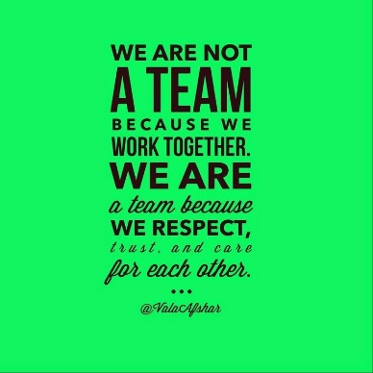
Another key skill in these scenarios is to ensure all members are involved and make equal contributions. It is common that some individuals will be less keen to voice their concerns, while some may speak a lot, the skill is to distribute the talking time across the group. Briefings can be an extremely powerful tool in motivating your team members and aligning the organization’s objectives with your teams’.
Take this opportunity to motivate and get your team going for the day. Use inspirational quotes and talk about something positive before you end the meeting it’s great and probably best if the team leaves the meeting smiling and laughing it will set the trend for the day.

JULY DOM DEAL

Please note the below T’s and C’s and ensure that you understand and know how to explain to clients.
July 2018 Big Deal Terms and Conditions
July 2018 Big Deal Terms and Conditions: Smart Broadband Wireless Uncapped All Hours & Business Hours.
Standard Fair Usage Policy (FUP) applies across both the SmartBroadband Wireless Uncapped All Hours & Business Hours products whereby on the 1st of each month customers will receive 150 GB of data that allows for an up to 10Mbps speed and once the 150GB is depleted then an additional 50GB of data is provided at an up to 4Mbps speed and once the 50GB/4Mbps bundle has been depleted the service then provides uncapped data at an up to 2Mbps speed for the remainder of the month. Peer to peer and NNTP type protocols are further speed restricted.
The SmartBroadband Wireless All Hours & Business Hours products utilize a wireless radio network to provide Broadband service and as such no speeds are guaranteed and service is provided in a strict best effort manner. Factors such as those in point 40 above prevail.
The SmartBroadband Wireless Uncapped Business Hours product will provide service strictly between Midnight – 5:00 pm 7 days per week. The service will not operate from 5:01pm to 23:59:59am, the LTE/LTE-A Once-Off data bundles can be purchased to access service beyond the standard times of operation. LTE/LTE-A Once- Off bundles purchased to provide service and be utilized from 5:01pm to 23:59:59 am to allow internet access.
ASSESSMENT LINK
https://goo.gl/forms/8KBeWVDkxloQM8dX2

