Empathy vs. Sympathy: The Secret to Delivering Exceptional Customer Service

How can you ensure that you’re delivering top-notch customer service?
Good customer service is built on a foundation that demonstrates an organization can be trusted. That the customer will be treated fairly and reasonably when approaching the company with problems and complaints.
What that means for you as a sales agent, is that you should know how to respond in a positive way. That will lead to a pleasant interaction and ideal outcome for both you and the customer. The key to all this is learning how to empathize with your customers
A critical component of building strong customer service skills.
Difference between Empathy and Sympathy (and Apathy)
Understanding the different emotions that are often conveyed in customer service communications is your first step in learning how to enhance your skills.
Comparison chart: Empathy vs. Sympathy (and Apathy) (Suggestion print and keep this chart in your store for future reference).
Empathy | Sympathy | Apathy
Understanding what others are feeling because you have experienced something similar or can relate to what they’re going through. | Sympathy is feeling compassion, or condolence, and agreement but without a personal connection. | Lacking interest or enthusiasm, a total indifference to others.
“I know it’s not easy. I have faced the same problems myself. Here’s how to fix it.” | “I’m so sorry that happened. But I’m afraid there’s nothing I can do to help.” | “No, there’s nothing I can do.”
Empathy makes a connection through a common experience or problem which you can resolve. | Sympathy shows you pity the person, but have no intention of helping them sort out the issue. | Apathy is the complete absence of emotion or caring for a person, place or thing.

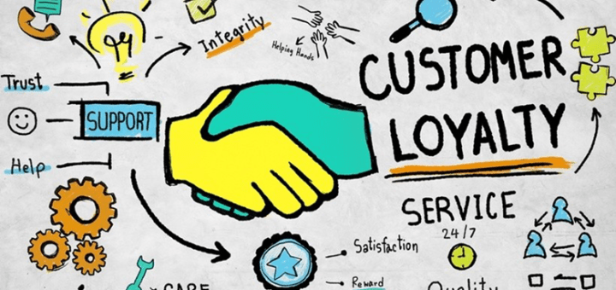
Why Empathy Is Important in Customer Service
In live chat, or any other customer service setting, the context of the language used to communicate has a direct effect on how your customers perceive the services they receive.
Empathy can be a tool used to help build trust with customers and provides them with reassurance that their problems and concerns are going to be resolved to their satisfaction. Understanding your customer’s needs, what they are trying to achieve, and what they are going through is critical to delivering a great experience.
Both empathy and sympathy suggest caring for another person, but with empathy, the caring is expanded by putting yourself in the customers’ shoes and being capable of understanding what they are feeling in that moment. Empathy is the act of relating to another person on a cognitive, emotional and compassionate level. It’s a building block of trust and therefore garners loyalty.
Sympathy is a detached recognition that the customer is upset about something. The differences between empathy and sympathy could be summed up as “I understand your pain” vs. “I’m sorry you’re in pain.” Sympathy is not usually seen as being particularly sincere or helpful and has little place in customer service.
The difference between empathy and sympathy is quite clear with empathy definitely being a more welcome response in customer service. However, there is rarely (if ever) an appropriate time to use an apathetic response. Apathy tends to breed contempt, which will never result in a positive outcome for you, your customer or the company you work for. If it ever gets to that point, your customer service skills may have gone on hiatus which is the single greatest indicator that you need some time off from work. It’s best to take a break before your responsiveness ever reaches the point of apathy.
How to Become More Empathetic:
For some, being empathetic towards others, or being an “empath,” comes naturally. It is something simply built into their DNA. But with some dedication, time and practice it is a skill that can also be learned.
It’s important to note that being empathetic to a customer’s situation does not necessarily mean that you need to agree with your customer 100% of the time. What you do need is the ability to see their point of view—even if it differs from your own—and provide a reasonable solution to their problem.
Each customer is different, and considering their unique situation is important. While handling a difficult live chat, ask yourself these questions:
- Why is this issue so important to this person?
- What made them feel the way they do?
- How has this problem caused hardships for this person?
- Who is this person in their day-to-day life?
- How would I feel this were happening to me?

When you can relate to your customer on some level, you start to build common ground, and genuine empathy can develop from there. By taking a moment to imagine where they’re coming from, you will be better equipped to respond in ways that are respectful and offer appropriate solutions.

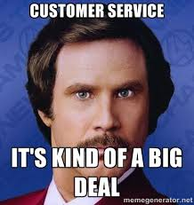

Try practicing empathetic phrases, using the examples below. Practice with your team and then try with customers.
“I understand. I would feel the same in your situation, but we will sort this out for you.”
“I know how frustrating it is. That happened to me once and I felt…, but once this is resolved, you will definitely be able to…”
“I absolutely agree. Let’s work together to fix this…”
“I understand why you’re upset, I have had that happened to me too. This is what I did to resolve the issue…”
“Sorry that happened! I know it’s how upsetting it can be when… Here’s what I will do to make sure it doesn’t happen again.”

Empathy isn’t only about dealing with adverse situations. You can show empathy towards your customers in a variety of ways for a variety of purposes.
For example, empathy:
- Makes you more open-minded and easy-going with customers.
- Can help demonstrate that you care about something personal they’re going through.
- Helps avoid arguments that could lead to escalated disputes.
- Allows you to see past an immediate problem to discover underlying issues.
- Provides an opportunity to offer alternate solutions that better meet their needs.
- Creates deeper, more authentic relationships with your customers.

Summary
Remember good customer service involves treating the customers with a friendly attitude. Excellent customer service means going above and beyond. It entails having a thorough knowledge of the store’s inventory in order to help customers make the best decision. Create repeat customers by answering their questions efficiently and following up with all requests. Ultimately, your goal as a customer service professional is to keep your customers happy. A happy customer is a customer who helps make your interactions smoother and who will keep coming back, ensuring the growth and success for you and your company for years to come.

ONLINE ASSESSMENT
https://goo.gl/forms/YtDKD4p5FfdYrgmz2

