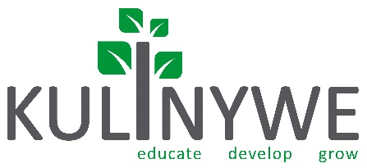

Engaging Alternatives to ‘Can I help you?’ [Increasing Retail Opt-Ins by Asking Better Questions]
TEST LINK: https://goo.gl/forms/pwwXC2mtuDIrMAjw2

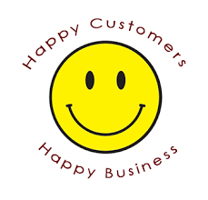
If you’ve spent much time working in a face-to-face sales environment, you know that asking “Can I help you?” is the best way not to get a customer to take you up on your offer. In stores, the customary response to that greeting is “I’m just looking.” Generic questions like “can I help you?’ do nothing for encouraging the retail opt-ins we need to grow our business.
We need better questions to ask our customers. It goes without saying that “How can I help you?” is a closed-ended question – one that can only elicit a yes or no answer. And when it comes to parting with money, people are inclined, by default, to say “no.”
We can win more sales just by asking more effective questions. Specific, focused, questions that urge interaction are the kinds of questions that will help you get your customers’ attention and make subsequent sales.
That means alternatives to “can I help you?” become a huge part of your marketing strategy.

In this lesson, we’ll take a look at the following ways to help you skirt around the dreaded question, “can I help you?”
- Understanding why “help” isn’t wanted
- 25 Alternatives to ‘can I help you?’
- A note on the importance of context
- Establishing credibility
- Following the steps
- Why sales is about engaging, not interrogating
Asking the right questions will go a long way toward helping your double your profitability.

Let’s delve into the most profitable types of questions to ask your customers.
Understanding why ‘help’ isn’t wanted
Establishing the best way to start sales conversations involves a little bit of introspection on your part.
When YOU enter a store to do some shopping, what do you typically say in response to the question “how can I help you” any of its many variants?
If you’re like most people, you typically say, “I’m just looking” or “I’m just killing some time” when asked that question, right?
Thinking about your own experiences in the role of consumer can readily inform your words – and actions – in the role of salesperson.
What questions are you more receptive to? Chances are, you are looking firstly for acknowledgement that you have some opinions or ideas about a potential purchase. Secondly, you’re likely looking for someone to hear your questions and respond to them, rather than make a cold offer. Your customers are going through precisely the same thought process.
When a customer enters a store , for example, they are fully expecting the disengaged, and typically unfriendly sales person running the place to ask the fabled question, “How can I help you?”
That said, we all tend to expect something different in different sales environments. As an example, you expect to be offered food in a restaurant. You expect to be offered a membership when you walk in a gym. You expect to be sold a car when you visit a car lot. When a sales person approaches you in any of those situations, you know they ultimately want to transact business.
No matter what kind of business you are in, there is a psychological stigma to go up against. What’s really happening is customers visit your location or website because they do, in fact, want to make a purchase. They just don’t want to be overtly “sold.” When you approach them with “how can I help you?” you do nothing to separate yourself from the predictable salespeople of the world.

If you go with a dry, overly formal, “all business, all the time” line of questioning, you’ll get a resistive response from your customers – the kind of predictable reaction that ultimately doesn’t lead to the customer opting in.
Starting a sales conversation off that way sets up the whole interaction for possible failure. To get things off on the right front when approaching new customers, you’ve got to be creative.

Alternatives to ‘can I help you?’
We’ve put together this collection of sales questions with the idea that you’ll look for ways to use them in appropriate situations. You can’t take one of them and use it for every customer, or every situation. But you could keep them in mind in certain contexts. More specifically, perhaps roll them around in your mind and figure out ways to apply them in different sales conversations.

Here’s a list of 20 sales questions for various customer engagements. Not that parentheses indicate that you should fill in the blank with whatever works contextually.
- What brings you in today?
- What kind of project are you working on right now?
- What’s more important to you (‘A’ benefit) or (‘B’ benefit)?
- Do you prefer (blue) or (yellow)?
- What are you trying to get (this devices/tool) to do?
- For whom are you buying this (gift/present/item)?
- Are you the only one who will use this (item)?
- Will you be using this (item) at home or for business?
- What features are most important to you?
- Are you looking more for savings or durability?
- Are you planning to do some travelling?
- Do you need a backup device?
- Is this your first visit to Telkom?
- Are you just starting out (with this product/service)?
- Have you used one of these devices before?
- What are your concerns?
- What alternatives have you looked at?
- What is your desired outcome?
- Are you familiar with this (technology/service)?
- Are you happy with your current provider?

These questions may read as being a bit random, but again, you have to think in terms of context.

An example of the importance of context
Context is really a key takeaway here.
As a great salesmen you need to be a master of asking the right kinds of questions. Greeting customers with a friendly smile.
When you are selling you need to ask questions relating to the sale and the items the customer is buying. If you are selling a post-paid, ask if the customer has children explain to them that if they took some pre-paid for their kids they could call their kids for free and the kids could call each other for free.
If the customer has come in for deal of the month ensure you also direct them towards other offerings in-line with the DOM deal. For example if the DOM is data related ask about their data usage and cross or upsell.
Drive add-ons and increasing items-per-transaction. Not with cold selling. But by warming up to the customers and using context to sell more items.
And that’s the main focus here: seizing each retail engagement to drive opt-ins, sales and revenue. It’s not rocket science; it’s common sense!

Establishing credibility
Every sales transaction needs to start with credibility. Lack of credibility is the main reason for missed sales opportunities.
An essay that appeared in The Journal of Personal Selling & Sales Management in 2001 stated the following:
“Trust in a salesperson requires a belief that the salesperson can be relied on to behave in a manner such that the long-term interests of the customer will be served (Crosby, Evans and Cowles 1990).”
And that’s ultra-important, frankly. You’ll never gain any ground with a prospective customer, unless you can first earn his or her trust. That logic has to shape and temper the questions you ask.

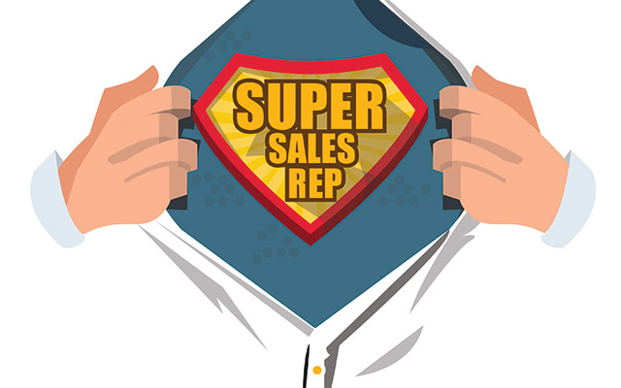
One of the worst ‘no-no’s in retail conversations is taking out of your depth. Sadly, this is how it goes for some.
A customer walks into a store.
Salesperson: “Hi! How are you?”
Customer: “I’m good. I’m actually confused, maybe you can help me.”
Salesperson: “I can try.” (Already evincing a lack of confidence!)
Customer: “I need something that will let me connect to the internet, Steam Movies and series, through my TV. Do you have anything like that?”
Salesperson: “I think so. We have some boxes that do that type of thing, but I’d need to know what kind of plugs each of your devices has.” (Zeesh!)
Customer: “Well, I mean, I need something that will work tonight. I’m having a party and I need to entertain some college students!”
Salesperson: “Let me ask my manager.”
The salesperson’s core mistake is, of course, not knowing his or her product offering well enough to offer a solution.
There’s some low confidence language at play in our example: “try”; “I think”; “Let me ask…”
Those words are tell-tale signs that our fictional salesperson doesn’t have an answer.
Here’s a better hypothetical exchange that’s a bit more beneficially engaging:
Salesperson: “Hi! How are you?”
Customer: “I’m good. I’m actually confused, maybe you can help me.”
Salesperson: “Sure, that’s why I’m here.”
Customer: “I need something that will let me connect to the Internet and Stream Movies or Series through my TV. Do you have anything like that?”
Salesperson: “So do you just need to connect to the internet and stream movies and series though your TV, or might you need more?”
Customer: “Well, what else do you suggest?
Now, just by asking an appropriate qualifying question, the salesperson in this example is able to offer the customer a solution by clearly demonstrating a confident understanding of the question at hand.

Following the steps
Speaking of “qualifying,” let’s have a little Sales 101 session to recap the flow of a real sales engagement, so that we can establish some of the best kinds of questions to ask at each stage in the process.
The basic sales conversation has a few variations, but it is generally as follows:
- Greet
- Qualify
- Present
- Close
You’ll also find that some add “Overcome” after “Present” to allow for any objections that arise, but most people tend to think of overcoming as an extension of presenting.
Here’s an example sales engagement dialogue:
A customer walks into a store.
Salesperson: Hi! How are you?
Customer: I’m good. How are you?
Salesperson: I’m doing great! Thanks for asking.
Are you looking to change your service provider or upgrade your mobile today?
Customer: Actually, I’m just looking for a new case for my iPhone.
Salesperson: Great! We have several to choose from here. Please follow me. Which iPhone do you have?
Customer: Ahh, I’m old school. I still have the iPhone 6.
Salesperson: Hey, that is old school! Do you know that phone won’t work with iOS 11 when it comes out later this year?
Customer: Really? I heard about the upgrade on the news. Seems like it has some cool features – I love the hand-off feature! I could use it with my iMac.
Salesperson: If you’ve had that iPhone 6 since it came out, you’re eligible for an upgrade to the iPhone 8S. How long have you had your 6?
Customer: I’ve had it for more than two years.
Salesperson: How about I pull up your account and see if you can upgrade today?

From there, the salesperson will, ideally, proceed through the process of upgrading the customer to the current iPhone. Note that the dialogue in our example is very natural and non-threatening – and not overtly salesy. It also hinges, as you might have noticed, on asking questions. And that means real conversations.
It’s important to respond to the customer’s needs (like showing the customer to the item that brought them into your store). But there’s nothing stopping you from taking the sale to the next level by asking probing questions.
Now, let’s take a closer look at some of the key questions in our store, and consider how those questions fit with the stages of the sales process.
Greeting:
“Hi! How are you?”
There’s no reason to try and reinvent the wheel. There’s no shame in simply being personable.
Qualifying:
“Are you looking to change your service provider or upgrade your mobile today?”
This question substitutes for “can I help you?” quite cleverly. Taken in the course of conversation, it will come off sounding a lot like “can I help you?” only it has an almost throw away suggestive quality. Such a question hints at what someone who wanders into a Telkom store might actually be looking for: a feature-rich new phone. The question also plants a “seed” thought in the shopper’s mind, leveraging the power of suggestion.
“Which iPhone do you have?
The salesperson seeks to solve the immediate problem first.
“Do you know that phone won’t work with iOS 11 when it comes out later this year?”
This question leads to an upsell. The customer originally came looking for an iPhone case. Now, the salesperson is poised to up the sale to a more expensive item. (Ideally, you will still sell the customer a case, albeit one for an iPhone 8S).
“How long have you had your (iPhone) 6?”
This question rounds out the qualification step by eliciting an answer that confirms the customer is, in fact, within the upgrade window for most carriers.

“How about I pull up your account and see if you can upgrade today?”
This question connects back with the second question the salesperson asked. Assuming the answer is “sure, go ahead,” the salesperson would then have the opportunity to Present iPhones and plans and Close the sale.
Please note, this example can be applied to the sale of almost anything in store. More importantly, please note that each step in the process is carried forward by asking questions.

Why sales is about engaging, not interrogating
With all this focus on “questioning,” it’s very easy to get caught up in the interrogation aspect of sales engagement.
That’s a bad idea.
Surely, you’ve encountered a salesperson who has asked way too many questions. Remember how that made you feel? Not so good, right?
Salespeople who approach customers with an endless onslaught of questions send a clear signal to their customers – that they aren’t real people. You want to avoid that, so make sure the questions you ask move the engagement forward.

As a rule of thumb, if you wouldn’t ask a question in casual conversation with someone you know, it’s not a good question in a sales conversation.
Treat people like equals and, above all else, keep it real.

